Practical 5
Part A — Practice Programs (Hour 1) :
Problem Defination :
1. Shape areas: an abstract Shape with abstract area(); subclasses Circle, Rectangle,
Triangle. Put a mix in a Shape[] and loop once to print each area and the running total,
tracking the largest — one loop handling every shape through polymorphism.

Solution:
abstract class Shape{
abstract double area();
abstract String getName();
}

class Circle extends Shape{
double radius;

Circle(double radius) {
this.radius = radius;
}

double area() {
return Math.PI * radius * radius;
}

String getName() {
return "Circle";
}
}

class Rectangle extends Shape{
double length, width;

Rectangle(double length, double width) {
this.length = length;
this.width = width;
}

double area() {
return length * width;
}

String getName() {
return "Rectangle";
}
}

class Triangle extends Shape{
double base, height;

Triangle(double base, double height) {
this.base = base;
this.height = height;
}

double area() {
return 0.5 * base * height;
}

String getName() {
return "Triangle";
}
}

public class Main {
public static void main(String[] args) {
Shape[] shapes = {
new Circle(5),
new Rectangle(4, 6),
new Triangle(8, 3)
};

double total = 0;
double largest = 0;

for (Shape shape : shapes) {
double a = shape.area();
System.out.println(shape.getName() + " Area: " + a);
total += a;
if (a > largest) {
largest = a;
}
}

System.out.println("Total Area: " + total);
System.out.println("Largest Area: " + largest);
}
}
OUTPUT :
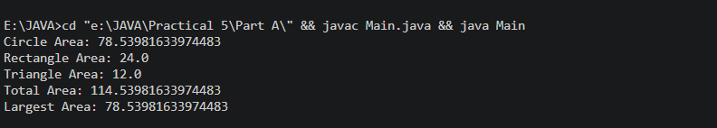

2. Payroll: an abstract Employee with abstract monthlySalary(); FullTime (fixed), PartTime (hours × rate) and Intern (stipend), each calling super for the shared name/id. Loop a mixed array to print each salary and the total; use instanceof to add a note only for interns.

Solution :
abstract class Employee {
String name;
int id;

Employee(String name, int id) {
this.name = name;
this.id = id;
}

abstract double monthlySalary();
abstract String getEmployeeType();
}

class FullTime extends Employee {
double fixedSalary;

FullTime(String name, int id, double fixedSalary) {
super(name, id);
this.fixedSalary = fixedSalary;
}

double monthlySalary() {
return fixedSalary;
}

String getEmployeeType() {
return "FullTime";
}
}

class PartTime extends Employee {
double hours, rate;

PartTime(String name, int id, double hours, double rate) {
super(name, id);
this.hours = hours;
this.rate = rate;
}

double monthlySalary() {
return hours * rate;
}

String getEmployeeType() {
return "PartTime";
}
}

class Intern extends Employee {
double stipend;

Intern(String name, int id, double stipend) {
super(name, id);
this.stipend = stipend;
}

double monthlySalary() {
return stipend;
}

String getEmployeeType() {
return "Intern";
}
}

public class Main2 {
public static void main(String[] args) {
Employee[] employees = {
new FullTime("Feni", 101, 50000),
new PartTime("Hasti", 102, 80, 300),
new Intern("Riya", 103, 15000),
new FullTime("Neha", 104, 45000)
};

double total = 0;

for (Employee e : employees) {
double salary = e.monthlySalary();

System.out.println(e.name + " " + e.getEmployeeType() + " Salary: " + salary);

if (e instanceof Intern) {
System.out.println("Note: This is an Intern");
}

total += salary;
}

System.out.println("Total Salary: " + total);
}
}

OUTPUT:

